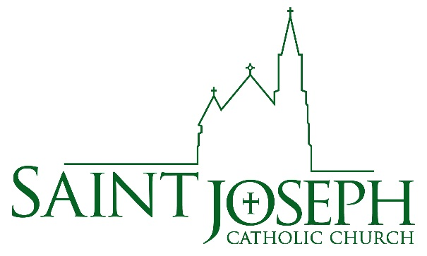

Godparent Form

I, _________________________________________, have been asked to be a godparent for
(please print your name)

(please print child’s name)
_____________________________________________, who will celebrate the Sacrament of

Baptism at St. Joseph Catholic Church.

As godparent, you are called to be: 1) a spiritual role model, 2) an example of the Christian life and 3) the official representative of the Body of Christ, the Church, into which your godchild is being baptized. You will be a source of guidance, support, and inspiration to this child on his or her faith journey and help the parents in the Christian formation of this child.

Please circle YES or NO:

YES NO I am at least 16 years of age or have received a special exception from the pastor.

YES NO I have received the Sacraments of Holy Eucharist and Confirmation in the
Catholic Church.

YES NO I have taken a baptismal preparation class at St. Joseph, or fulfilled the
requirements of my home (attach letter from your parish).

YES NO I will be present at the Baptism. If not, ________________________ will stand in
as proxy for me.

YES NO I am not Catholic, but am baptized in another Christian denomination. I
understand that I cannot be a godparent, but can serve as a Christian witness.

Answer only if you are married:

YES NO My marriage has the blessing of the Catholic Church.

I affirm that I meet the qualifications, and accept the responsibilities, of being a godparent. I am an active and participating Catholic and promise to the best of my ability to serve as an example in encouraging this child to participate in the sacramental life of the church.

Godparent’s signature: ________________________________________ Date: ____________

Phone: ________________________ Email: ________________________________________

