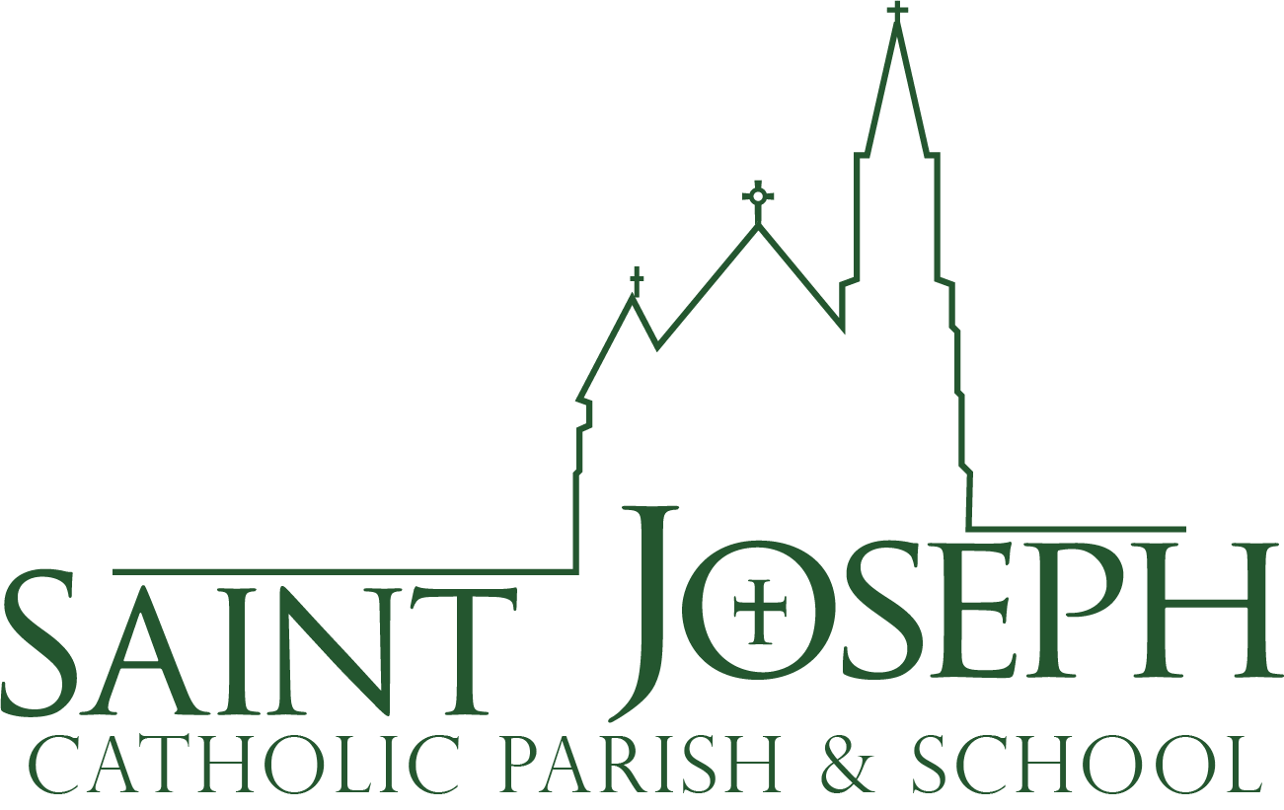 **middle school**

**youth group**

**2023-24**

**Grades 6-8**

Middle School Youth Group information:

* + MSYG will typically be the 2nd, 3rd & 4th Wednesdays of the month from **6:30-8pm.** The 1st Wednesday is typically training night for our leaders.
  + MSYG will meet in **Saint Joseph School.** Students will enter into the gym off Meldrum Street and check-in
  + Small groups will be led by trained high school 10th, 11th, & 12th graders overseen by a group of adult leaders.
  + Our curriculum will be **Lectionary Based Catechesis**, meaning we will use the upcoming Sunday Mass readings as our content. Students will split into grade-specific small groups where they will read the Sunday readings directly from the Bible and spend time unpacking the meaning.
  + The general outline for a night will look like this:
    - Open gym time as kids arrive
    - Opening prayer, 60 seconds with a Saint, and introduction to the theme of the readings in large group.
    - Small group grade-specific breakout time to read the readings and unpack the meaning.
    - Short activity break halfway through the night to re-energize and focus on community-building.
    - Closing prayer and announcements in large group.
  + Students are asked to participate in a **one-on-one meeting** with Chad in Oct/Nov. This originated from the individual meeting that typically happens the year students are Confirmed. It’s a great time to discuss Faith, ask questions, and talk about upcoming opportunities. The meeting will take place in a public place, typically a coffee shop.
  + Encouraged to participate in service opportunities during the year.

**Schedule for 2023-24**

**September** 27(kickoff)

**October** 11, 18, 25

**November** 8, 15, 29

**December** 13, 20

**January** 17, 24, 31

**February** 14*, 21, 28

**March** 20, 27*

**April** 10, 17, 24

**May** 1

*\** **February 14** is Ash Wednesday; we’ll attend Mass together

**\* March 27** is the Seder Meal, location TBD

MSYG is on Wednesday nights from **6:30-8pm** in Saint Joseph School; enter the gym from Meldrum St.

Students need to bring their Bible each night.

Each student is given a Bible in 6th grade; they will be handed out the first night of class.

**Contact Information**: [cbauer@stjosephfc.org](mailto:cbauer@stjosephfc.org) 970-482-4148 ext. 218